**Name:Ch.Rohith**

**R.no:2403A52178**

# TASK DESCRIPTION #1

write a python code that arranges the elements in ascending or descending order in an list and also the bubble sorting.

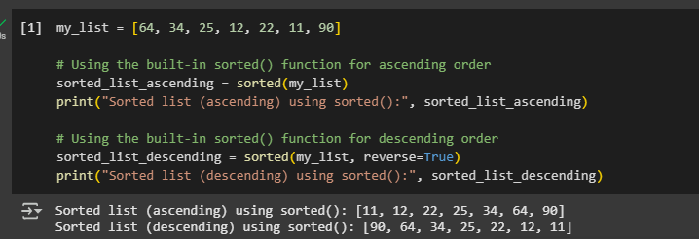

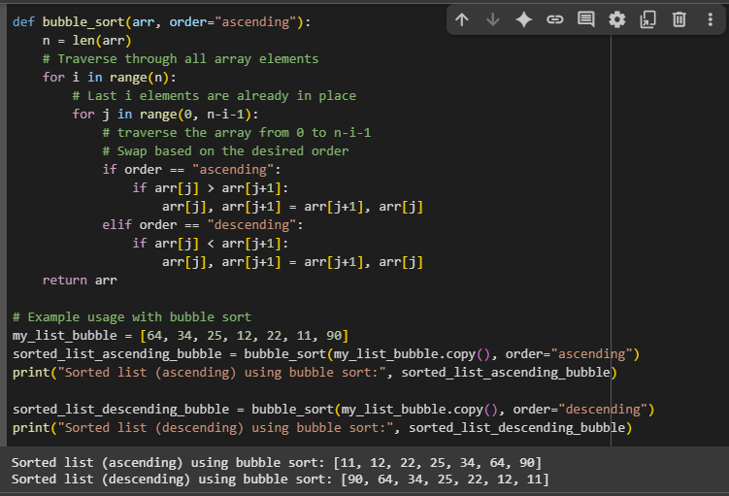

# TASK DESCRIPTION #2

write a python code which accept the string and give the no of vowels , no of consonants, and the no of digits in th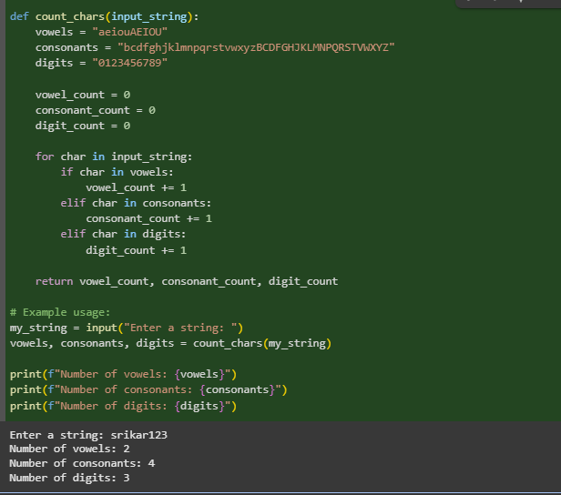e string.

Output1:

Output2:

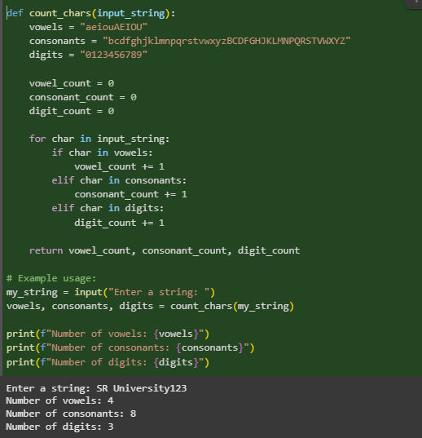

# TASK DESCRIPTION #3

write a python code that generate an empty text file and allows me write into the file and display it back

output1:

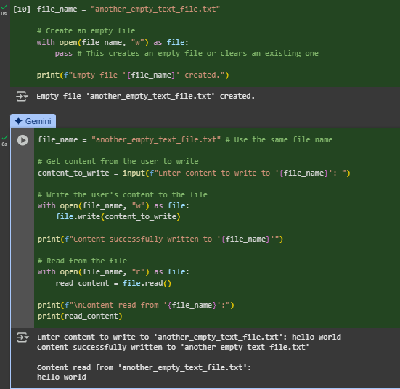

Output2:

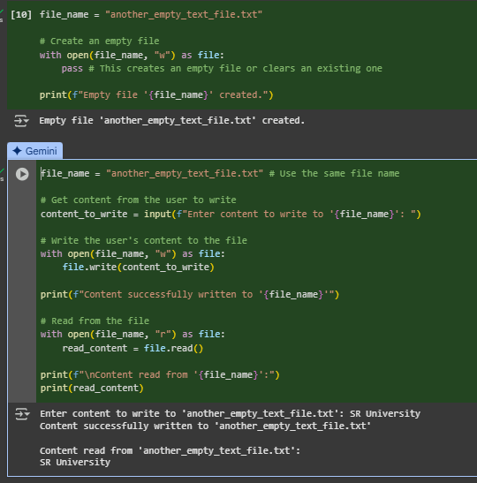

# TASK DESCRIPTION #4

write a python code that generate an simple calculator like add, subtract, multiply and divide and ask user input and also explain how does the code work

Output1:

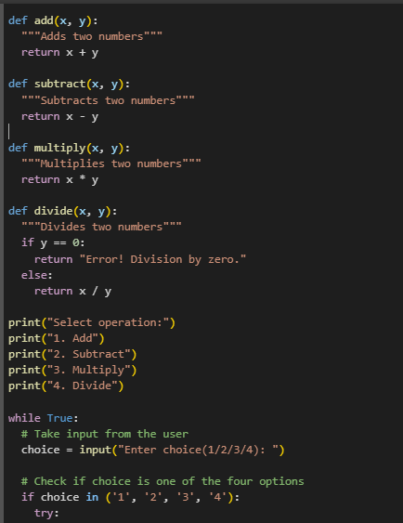

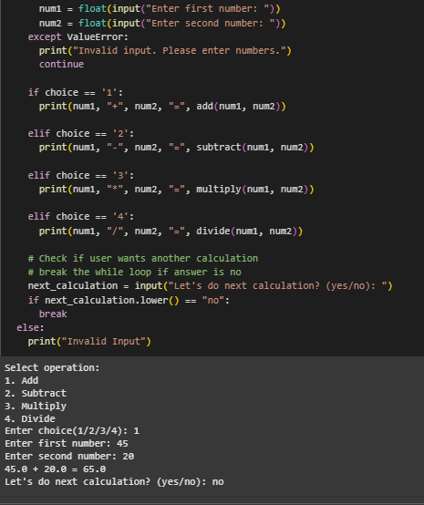

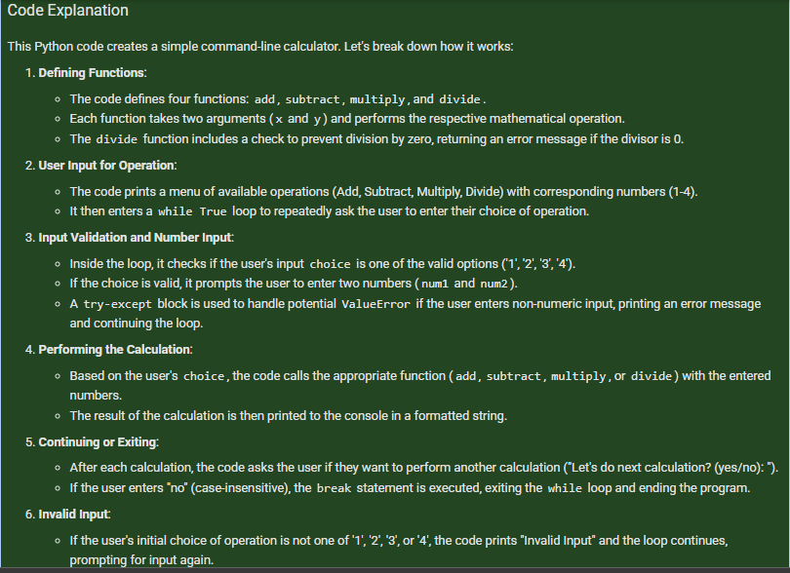

# TASK DESCRIPTION #5

Use gemini to create a python program that checks if a given year is a leap year or not .try different prompt styles and see how gemini modifies its code suggestions.

OUTPUT:

A functional program to check a leap year with sample input/output

• At least two versions of the code from different prompts

• A short comparision of which version is better and why



